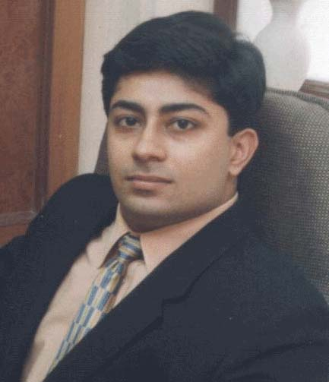

Dr. Anand Krishnamurthy

He is an Executive committee member of the Indian academy of Osseo integration (IAO),

Member of Indian Academy of esthetic & Cosmetic Dentistry,

Member of Indian Society of Oral Implantologist.

He is the Opinion leader for Dental Company Bisco international

He is the Key opinion leader for AB dental implants (Israel)

Fellowship of International congress of Oral Implantologists (ICOI)

