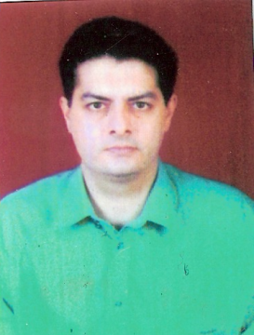

Dr Nariman R Kavina

Specialty: ORTHODONTIST

Advance Orthodontic courses-

- The Advanced MBT System
- Indirect bonding
- Contemparary Orthodontic Designs
- Recent advances in Orthdontics
- The MBT Orthodontic System
- The Straight Wire Appliance Advanced Course
- Interdisciplinary Orthdontics
- Orthodontic Mechanics-
- Self Ligating Appliances
- Functional Occlusion
- Lingual Orthodontics
- Twin Block

