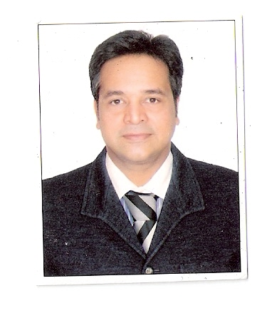
DR SHAILESH SHENAVA

Specialty: ORTHODONTIST
- Pre Adjusted Appliance
- Self Ligating
- Invisalign
- Lingual Orthodontics
- Myofunctional Appliances

EXPERIENCE

- LECTURER IN DEPARTMENT OF ORTHODONTICS AT A.B. SHETTY COLLEGE OF DENTAL SCIENCE MAGALORE FRO ONE YEAR.
- PRESENTLY AT SANJEEVANI HOSPITAL
- HON. CONSULTANT AT GOKULDHAM MEDICAL CENTRE, MUMBAI
- HON. CONSULTANT AT KESHAV CARE HOSPITAL, MUMBAI
- HON. CONSULTANT AT MANIPAL CURE AND CARE AT BANDRA AND LOKHANDWALA, MUMBAI

ADVANCED COURSES

- DONE A TWO HAND PRE-ADJUSTED APPLIANCE COURSE CONDUCTED BY THOMAS D CREEKMORE (U.S.A)
- DONE A COURSE IN SELF LIGATING APPLIANCE IN MANCHESTER (U.K) BY DAMON.

ALSO A MEMBER OF WORLD FEDERATION OF ORTHODONTISTS

