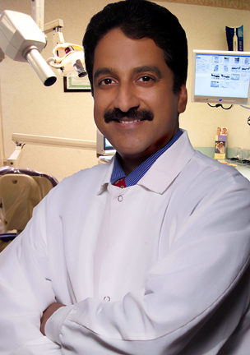
Dr. Shankar Iyer D.D.S., M.D.S.

President, Smile USA center of Reconstructive Dentistry, New Jersey
Director, Smile USA Center for Educational Excellence, New Jersey
Director, Maxicourse Asia
Diplomate, American Board of Oral Implantlogy
Clinical Asst Professor NYU, and UMDNJ
Editor-In-Chief, International Journal of Clinical Implant Dentistry
Board of Trustees, American Academy of Implant Dentistry
Honored Fellow, American Academy of Implant Dentistry
Past President, NE Dist. AAID
International Dentist of the Year 2007
Fellow, International Academy of Dento facial Esthetics
Editorial Board, Journal of Oral Implantology
America's top Dentists - 2006, 2008, 2009

