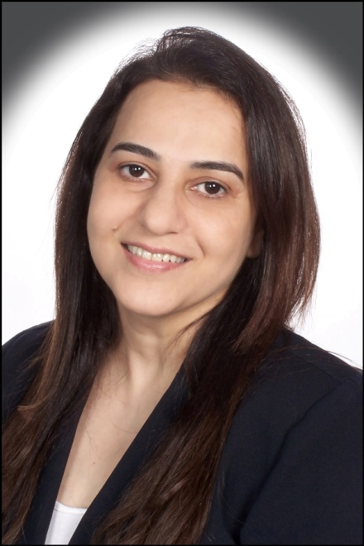

Dr. Zahra Hussaini

Faculty Academy of Oral Implantology

Laser Academy of India

Member of Oration Committee ,Research and Ethics Committee
and Advisory Committee of Cancer Aid and Research Foundation

Director and Trustee of Able Foundation.
A charitable foundation working for the physically and mentally handicapped. Conducted various health check up camps and awareness program.

SPECIAL TRAINING :
- ASSOCIATE FELLOW of American Academy of Implant Dentistry (AAID).
- DIPLOMA in Lasers
- COSMETIC DENTISTRY Postgraduate Certification – Special Attn: Smilemakeovers

Director of IHCEP (International Health Continuing Health Education Providers).
Coordinator of AAID ( American Academy Of Implant Dentistry) Maxicourse in Mumbai.

Conducted various dental check–up and oral health awareness camps in schools of Bombay and in rural areas of Maharashtra and Gujarat.
Was instrumental in bringing the brush biopsy test for early detection of Oral Cancer in India. With a mission to Save Lives in India.

Currently doing major research work in the field of Oral Cancer.
Honoured by the prestigious “ Glory of India Award” on “Parvasi Bhartiya Divas” in New Delhi for the outstanding achievement in the field of Dentistry.s

